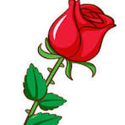Mrs. Stephanie & Mrs. Freedom’s Newsletter
April 26, 2024
What’s happening in our room?
This week Mrs. Freedom’s groups read an ocean animal book. The children tracked along the words as Mrs. Freedom read. Afterwards, they wrote the name of animal in the book. I was able to get some assessing done of letters, letter sounds, and counting. Next week, I’m playing CVC word Bingo and Mrs. Freedom’s conducting a science experiment.

What’s coming up:
May 6th – End of the year class picnic

May 9th – Student led conference nigh

May 14th – YMCA Swim Day

May 17th – Last Day of School

Need me?
sconnally@tcjackets.net Seesaw or 229-225-3908

